dmi:Design Value Award (DVA)
2019 Press Kit

Please feel free to use language, logos, and images on your website, social media posts, LinkedIn Company/Organization page and any printed or digital material related to the promotion of the Design Value Awards. You do not need to ask permission to use these materials to promote your DVA win.
Long Statement:
As the longest standing global institution of it’s kind, DMI holds an exclusive position in the Design and Design/ Innovation Management landscape. For 44 years, DMI has been an active advocate for the strategic value of Design. The organization brings together educators, researchers, designers, innovators, and leaders from every design discipline, every industry, and every corner of the planet to facilitate transformational organizational change and design driven innovation. Find more about the Institute at www.dmi.org

Short Statement:

The 2019 dmi:Design Value Awards recognize teams that have delivered significant value through excellence in Design or Design Management practices. The 2019 Design Value Award winners are exemplars in their fields; they are a distinguished list of organizations that include non-profit entities, government agencies, large multinationals, Universities, and regional enterprises.

Photos:
You may download Award photographs from the DMI Flickr page. You do not need to ask permission to use these photos.

https://www.flickr.com/photos/designmanagement/albums/72157710877504666

Graphics:

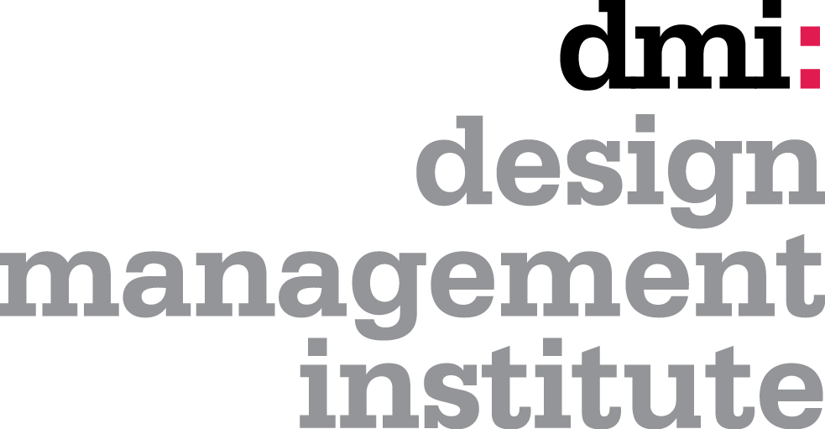

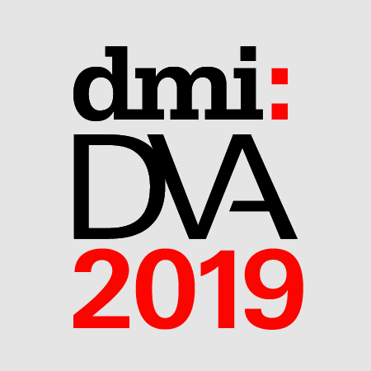

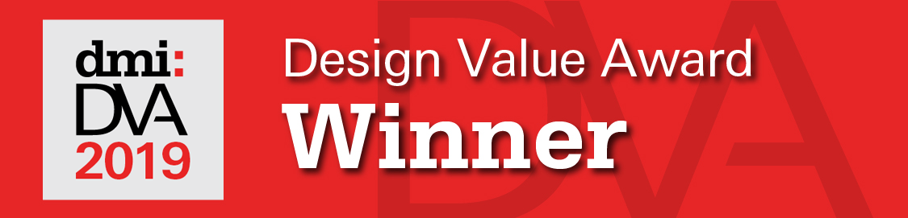
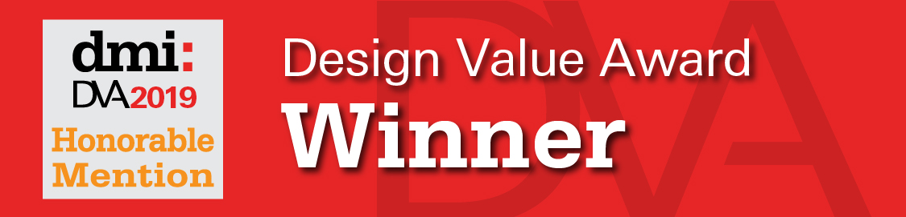

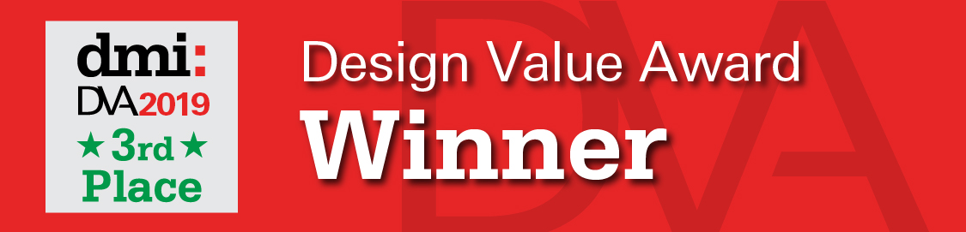

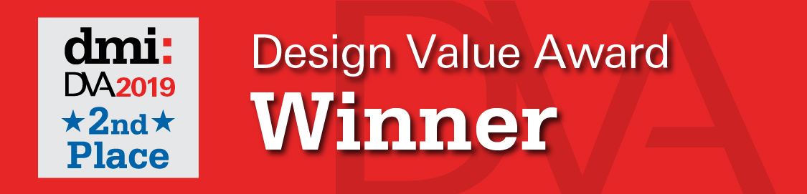

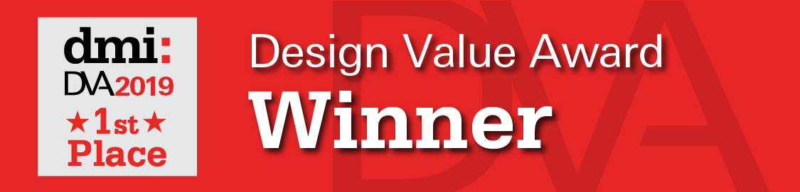

DMI Twitter Social Media Handle & Tags:

DMI: @DMIfeed https://twitter.com/DMIfeed
Conference Hashtag: #DLC19
Design Value Award Hashtag: #DVA19

If you have any questions or need more assets please contact:

Carole Bilson
cbilson@dmi.org

